Technical Automation Brief
Robotic Replacement of Manual Packaging / Bale Discharge Tasks

Prepared for: Robotic System Integrator / Automation Partner
Input basis: Video observation supplied by client
Document purpose: Technical specification for a fully autonomous robotic replacement system
Revision: v0.3 - fully autonomous system requirement, strap cutting clarified

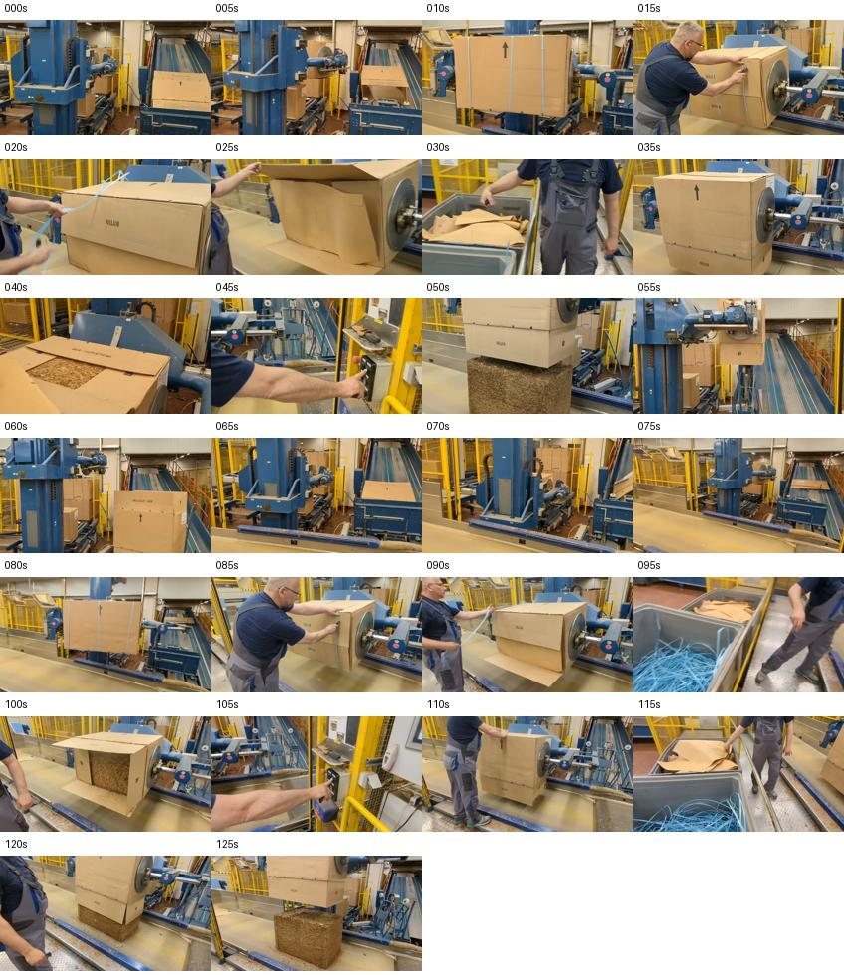
Figure 1 - Contact sheet from the supplied video showing the repeated manual cycle.

1. Executive Summary
The video shows a human operator supporting an industrial machine that processes a large cardboard-packaged compressed material block or bale. The operator does not appear to perform the heavy pressing or lifting operation; the machine performs that function. The human mainly performs variable packaging-preparation tasks: cutting/removing blue plastic straps, opening and folding cardboard flaps, handling loose inner cardboard/paper sheets, visually checking the state of the package, and initiating the machine cycle from the control station.
Important correction from video review: in Step 2, the blue plastic strap is cut by the operator. Therefore, the robotic concept should treat strap handling as a cut-and-capture operation, not simply a pulling operation.
The target requirement is a fully autonomous, fully automated robotic cell that replaces the current human operator for this process. The robot system shall independently detect package readiness, locate and cut the blue straps, capture and dispose of the cut strap pieces, open/fold cardboard flaps, handle inner sheets according to the defined process rule, verify the ready state by sensors/vision, and trigger the machine cycle through a validated PLC/safety interface. Human involvement shall be limited to maintenance, replenishment, abnormal recovery and safety-supervised service modes.
Item | Preliminary conclusion
Automation target | Fully autonomous replacement of the human operator for the packaging-preparation and machine-discharge initiation sequence.
Most automatable actions | PLC trigger, visual state check, controlled strap cutting/disposal, repetitive flap opening under controlled geometry.
Highest-risk actions | Locating/cutting tensioned straps safely, controlling loose strap ends after cutting, controlling large cardboard flaps, handling torn/deformed packaging.
Recommended approach | Design and deliver a production-ready autonomous robotic cell with vision, guarded strap cut-and-capture tooling, cardboard/sheet handling, PLC/safety integration, automatic sequence control, and defined abnormal recovery mode.
Integrator deliverable expected | Concept layout, robot/EOAT selection, PLC/safety concept, cycle-time estimate, risk assessment, FAT/SAT plan, autonomous-operation acceptance criteria and budget.

2. Observed Manual Process
The observed cycle can be decomposed as follows. Exact timestamps are approximate because the analysis is based on visual observation only.
Step | Observed human action | Technical interpretation | Automation difficulty
1 | Operator waits while packaged bale/box is positioned by the machine. | State detection: package present, fixture in safe position, robot access allowed. | Low
2 | Operator/robot locates the blue plastic strapping bands and positions a cutting/capture tool at the strap. | Detect strap location, confirm safe cut zone, cut the strap, and capture/contain loose strap ends. | High
3 | Operator/robot removes or guides the cut strap pieces away from the box after cutting. | Post-cut flexible material handling; risk of snap-back, dangling ends, tangling, or partial retention. | High
4 | Operator/robot transfers the cut strap pieces to a nearby bin/chute and releases them. | Waste-handling of cut flexible material; should be simplified with chute, capture cassette, or suction/collection device. | Medium
5 | Operator opens cardboard flaps by pulling/folding edges away from the bale opening. | Manipulation of large semi-rigid sheets; requires edge detection and compliance. | Medium-High
6 | Operator removes or folds away inner cardboard/paper liner sheet. | Sheet handling and classification: remove, fold, or leave depending on process rule. | Medium-High
7 | Operator visually checks package/bale state before starting next machine motion. | Machine vision inspection and state validation. | Medium
8 | Operator presses a control button on the machine panel. | Prefer direct PLC signal, not physical button pressing. | Low
9 | Operator observes discharge/transfer of compressed block/bale. | Safety and quality monitoring; machine state feedback. | Low-Medium
10 | Cycle repeats for next package. | Robotic sequence must handle variation across repeated packages. | Medium

3. Key Video Evidence / Process States
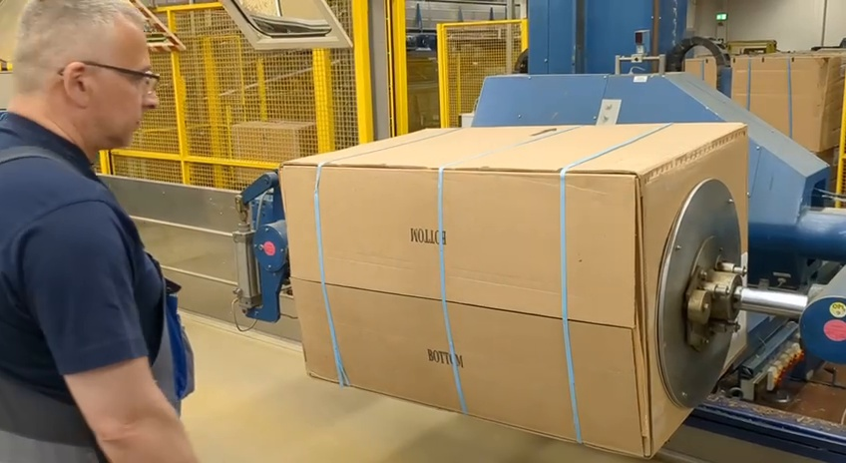
Figure 2 - Strap cutting begins at the side/front of the cardboard package.
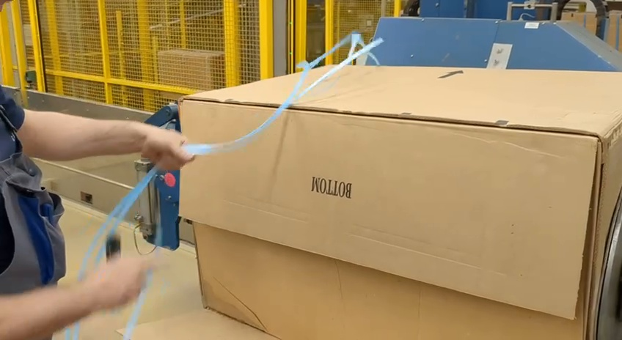
Figure 3 - Operator cuts the blue plastic straps and controls/removes the loose strap ends.
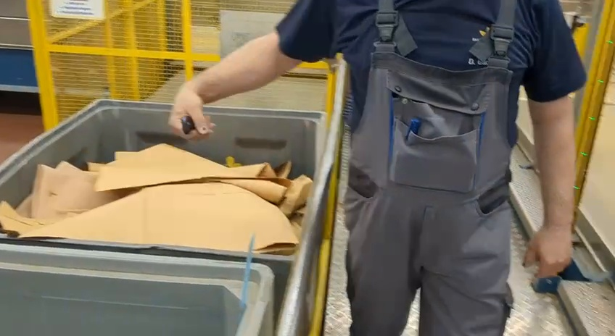
Figure 4 - Cut strap pieces are placed into a waste bin.
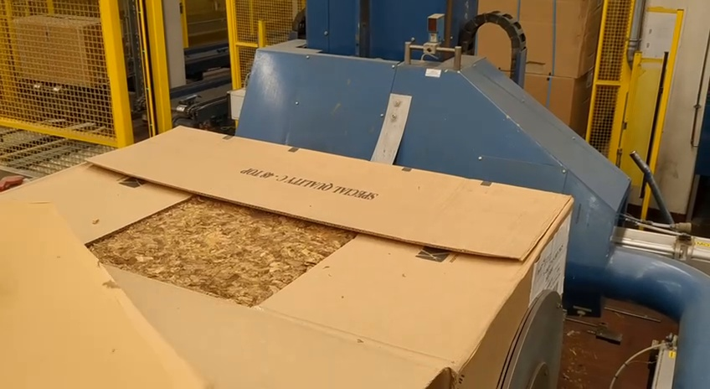
Figure 5 - Cardboard flaps are opened and the compressed material becomes visible.
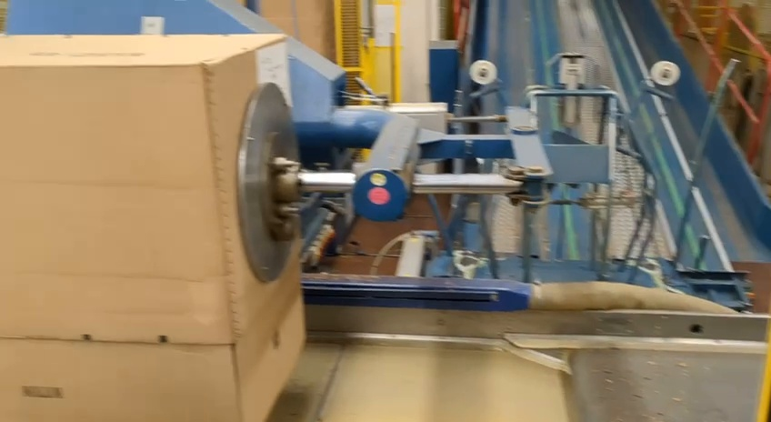
Figure 6 - Machine control button is actuated by the operator.
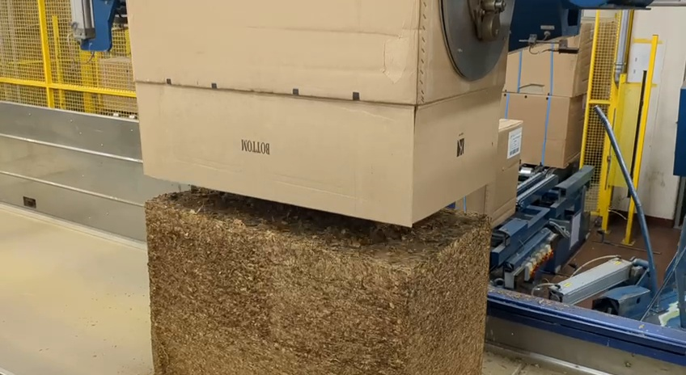
Figure 7 - Bale/material is discharged or lowered from the package area.
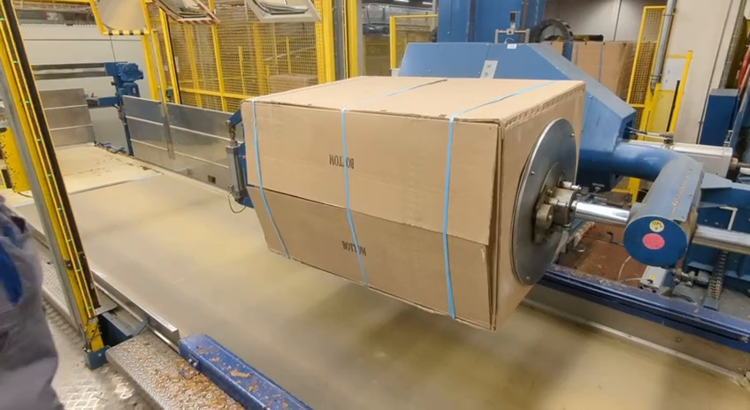
Figure 8 - Second cycle: operator again accesses and cuts straps on a new package.
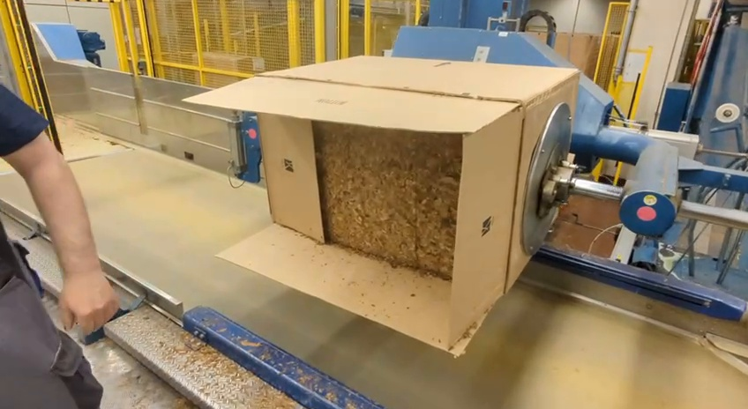
Figure 9 - Second cycle: package opened and compressed material visible.

4. Automation Objective and Scope
Primary automation objective: fully replace the manual operator intervention required to prepare the cardboard-packaged bale for machine discharge during normal production operation.
In scope | Out of scope / to be confirmed
Detect package position and readiness. | Modification of the core press/baling machine, unless PLC/safety integration requires it.
Locate, cut, capture, and dispose of blue plastic straps. | Final packaging design changes by the upstream supplier.
Collect/dispose cut strap pieces into a controlled waste channel or bin. | Autonomous recovery from catastrophic or non-standard package damage outside the agreed normal-production package specification; these cases shall enter a safe reject/recovery mode.
Open/fold cardboard flaps and clear access to bale. | Downstream palletizing or warehouse logistics, unless requested later.
Handle inner cardboard/paper sheets according to process rule. | Quality inspection of the compressed material beyond go/no-go discharge readiness.
Trigger machine cycle through PLC handshake after safety/state validation. | Physical button pressing as production method. Production solution shall use PLC/safety handshake.

5. Proposed Robotic Cell Concept
The suggested concept is a fixed industrial robot or collaborative robot installed adjacent to the existing machine, depending on reach, payload, cycle time and safety constraints. Because the task involves loose packaging material and interaction near an industrial machine, a full industrial safety concept is mandatory even if a collaborative robot is selected.
Subsystem | Recommended function
Robot manipulator | 6-axis arm with sufficient reach to access front/top/sides of package and waste disposal point. Preliminary payload target: 8-20 kg depending on EOAT.
End-of-arm tooling | Hybrid EOAT: vacuum pads for cardboard sheets/flaps plus guarded strap cutter with integrated capture/gripper for cut strap pieces.
Vision | 2D/3D camera for box pose, strap visibility, flap state, open/closed verification and bale exposure check.
Waste handling | Dedicated strap chute/bin with funnel, capture cassette, or active suction collection to reduce dangling strap movement.
Machine integration | PLC handshake: package ready, robot in safe zone, robot complete, machine cycle allowed, machine moving, fault/reset states.
Safety | Safety scanner/light curtain/interlocked guarding, safe zones, E-stop integration, safe torque off and validated safe robot position.
Operator HMI | Manual override, robot recover sequence, fault reason, camera image/status, maintenance mode.

6. End-Effector / Tooling Requirements
Task | Tooling concept | Design notes
Plastic strap removal | Guarded blade, hot knife, pneumatic shear, or cutter/capture device with strap guide. | Because the operator cuts the blue strap, the robotic design should prioritize safe cut positioning, guarded tooling, and immediate loose-end control.
Strap disposal | Gripper/capture release into bin, chute, suction tube, air blow-off, or integrated collection cassette. | Avoid long robot travel with dangling cut strap pieces if possible.
Cardboard flap opening | Vacuum cup array plus compliant wrist or mechanical paddle/finger. | Cardboard may be warped, dusty, torn, or low-vacuum. Provide compliance and fallback.
Inner sheet handling | Vacuum gripper or wide paddle with clamp. | Integrator must define whether sheet is waste, liner, or reusable protective component.
State verification | Camera-based check after each manipulation step. | Confirm straps cut/removed, loose ends contained, flaps open, bale exposed, robot clear.

7. Vision and Sensing Requirements
A robust system should not rely only on taught robot positions. The packaging appears variable; therefore the robot needs perception or at least sensor-assisted confirmation.
Vision target | Required output
Package pose | Box front face, side edges, orientation and position relative to machine fixture.
Strap detection | Blue strap location, number of visible straps, cut-zone confirmation, and cut/removal confirmation.
Flap state | Closed, partially open, fully open, obstructing discharge, or unknown.
Bale exposure | Compressed material visible and clear for discharge.
Waste bin/chute state | Optional: bin/chute present, not overfilled, cut strap pieces released.
Safety zone | Human presence detection must be safety-rated and should not rely on standard vision alone.

8. PLC / Controls Interface
Required control strategy: do not make the robot press the physical button as the production solution. Integrate the robot controller with the machine PLC through a validated safety-rated handshake so that machine discharge is requested automatically only after the robot has completed the full preparation sequence and verified the safe/ready state.
Signal / state | Direction | Purpose
Package_In_Position | Machine -> Robot | Machine fixture has stopped and robot access is allowed.
Machine_Safe_For_Robot | Machine -> Robot | No hazardous machine motion in the robot working zone.
Robot_In_Home_or_Clear | Robot -> Machine | Robot is outside machine danger zone; machine movement allowed.
Robot_Task_Complete | Robot -> Machine | Straps cut/removed, flaps/sheets handled; discharge may start.
Start_Discharge_Request | Robot/HMI -> Machine | Equivalent of operator button after validation.
Machine_Cycle_Active | Machine -> Robot | Robot must remain clear.
Fault_Code / Reset_Request | Bi-directional | Recoverable fault handling and operator intervention.

9. Safety Concept - Preliminary
The integrator must perform a formal risk assessment according to applicable EU machinery safety requirements. The following points should be considered at concept stage.
Hazard | Preliminary mitigation
Robot motion near operator or existing machine | Guarding, safety scanner, light curtain, interlocked gate, safe speed/position, E-stop chain.
Machine motion while robot is inside the working envelope | Safety-rated PLC interlock and safe robot clear signal.
Entanglement with plastic straps | Guarded strap cutting, controlled capture, jam detection, torque/force monitoring.
Cardboard jams or unexpected deformation | Vision confirmation, force limits, recovery mode, operator HMI prompts.
Dust/debris from compressed material | Protected cameras, tool filters, maintenance schedule.
Manual intervention during robot fault | Lockout/tagout procedure, teach/recovery mode, clear status lights and HMI guidance.

10. Required Autonomous System Delivery Scope
System area | Mandatory requirement | Integrator output | Acceptance evidence
Site and machine survey | Measure machine access, package variation, cycle time, safety zones, utilities and PLC/safety interface. | Survey report, layout constraints, I/O and safety interface list. | Customer approval of baseline data.
Autonomous robot sequence | Robot shall automatically execute the complete normal cycle: detect package, cut/capture straps, dispose straps, open/fold flaps, handle inner sheet, verify ready state and request discharge. | Robot sequence description, state diagram, simulation/reach study and cycle-time estimate. | Cycle simulation and sequence review approved.
EOAT and tooling | Provide production-grade strap cut-and-capture tool, cardboard flap/sheet handling tool, compliance and jam detection. | Tool drawings, risk controls, maintenance plan and sample test evidence. | Sample testing with real packaging material.
Vision and state verification | Use 2D/3D vision or equivalent sensors for package pose, strap location, cut confirmation, flap/sheet state and bale exposure check. | Camera/sensor layout, inspection logic, pass/fail states and lighting concept. | Detection and verification test report.
PLC, HMI and safety | Integrate robot, machine PLC, HMI and safety system. Machine cycle shall start only after validated robot-complete and robot-clear states. | PLC signal list, safety concept, E-stop/interlock design, HMI screen list and fault recovery logic. | Safety validation plan and PLC handshake test.
FAT, SAT and handover | Demonstrate fully automated normal production operation on an agreed package sample set, then validate on site with operators trained only for supervision, maintenance and abnormal recovery. | FAT/SAT protocol, acceptance results, manuals and training package. | Signed FAT/SAT and handover package.

11. Acceptance Criteria for Fully Automated System / FAT / SAT
Metric | Production acceptance target | Notes
Successful full cycle completion | >= 98% on agreed normal-production package set during FAT/SAT | The final customer requirement is autonomous operation, not assisted operation. Abnormal/damaged packages may be classified separately if agreed in advance.
Strap removal success | Cut + capture/disposal >= 98% for agreed normal strap conditions | Define cut location, acceptable remaining strap fragments, snap-back limits, and capture/disposal requirement.
Flap opening success | >= 95% for non-damaged boxes | Damaged/torn boxes should be separate category.
False machine-start prevention | 100% | Robot must not request discharge unless state is safe and ready.
Human intervention rate | No human intervention during normal accepted cycles | Human interaction limited to maintenance, replenishment, abnormal recovery and safety-supervised service mode.
Cycle time | Equal to or better than required customer cycle-time target | Robot cycle must not bottleneck the machine in normal production.
Safety validation | 100% mandatory | No production release without validated safety functions.

12. Information Required from Client Before Final Quotation
- Machine manufacturer, model, PLC type, electrical drawings and existing safety circuit documentation.
- Baseline manual cycle time and desired automated cycle time.
- Package dimensions, weight range, strap material/width/count/location, and photos of normal and abnormal packages.
- Clarification of permitted cutting method, cut location, blade safety concept, and whether cut strap pieces must be captured immediately.
- Clarification what must happen to cardboard flaps and inner sheets: discard, fold back, keep attached, or reuse.
- Available floor space, guarding limitations, operator access requirements and maintenance access requirements.
- Environmental conditions: dust, humidity, lighting, debris, cleaning requirements.
- Expected production volume per hour/shift and acceptable downtime/intervention rate.

13. Key Technical Risks and Recommendations
Risk | Why it matters | Recommended mitigation
Flexible strap unpredictability | Cut plastic straps can snap back, tangle, slip, or remain partially attached. | Use guarded cut-and-capture tooling; test with real strap tension, package deformation and damaged strap scenarios.
Cardboard deformation | Flaps may not repeat the same geometry after transport and compression. | Use vision + compliant EOAT; avoid pure position-based programming.
Unknown machine interface | Button pressing is easy but unsafe/fragile as a production strategy. | Request PLC/safety documentation early.
Dust and debris | Can degrade camera and vacuum reliability. | Protect lenses, add air purge if needed, select industrial vacuum components.
Edge cases | Damaged boxes or non-standard strap conditions can interrupt autonomous operation if not defined in the normal-production specification. | Define normal vs abnormal package envelope. Robot must autonomously handle all agreed normal cases and move abnormal cases into a safe reject/recovery state.

14. Preliminary Integrator Work Package
The robotic system integrator should be asked to provide the following as a first professional response:
- Concept layout drawing with robot position, access envelope, safety boundary and waste disposal concept.
- Recommended robot model and justification: reach, payload, IP rating, speed, controller options and safety functions.
- End-effector concept drawings for strap cutting/capture, cardboard flap handling and inner sheet handling.
- Vision/sensor concept including camera placement and inspection logic.
- PLC signal list and integration concept with the existing machine.
- Preliminary risk assessment and required safety hardware.
- Budgetary quotation split into engineering, robot/cell hardware, EOAT, vision, PLC/safety integration, build, FAT, installation, SAT and commissioning.
- Clear statement of assumptions, exclusions and required client inputs.

15. Open Assumptions
This document is based only on the supplied video. The exact machine type, product material, package design, production rate, available PLC interface and safety category are not yet confirmed. The requirement, however, is fixed: the final delivered system shall be a fully autonomous robotic replacement of the current operator task sequence during normal production. Any engineering tests, FAT or SAT activities are validation steps only and do not change the final autonomy requirement.

